WALMART FRONTLINE AI TRANSFORMATION
Quantitative Risk Assessment Using Indicators and Warning (I&W) Analysis
ALY-6130 | Group 9 | Blessing Idowu Jonathan | Isaac Oboikinome Ideho | Hao Mao | Ezinne Lynda Anyinofu | June 2026

1. Introduction
This report presents the quantitative risk assessment of three competitive risks identified for Walmart Inc.'s AI transformation initiative, using the Indicators and Warning (I&W) analysis technique. The I&W methodology is a structured intelligence-based approach that identifies observable indicators — measurable signals that suggest a risk event is developing — and warning thresholds that trigger management intervention. Applied within the COSO ERM framework, the I&W technique enables organizations to transition from qualitative risk identification to quantitative probability and impact estimation, supporting more precise risk-informed decision-making.
The three risks assessed are: R-001 (Market Share Erosion from Competitive AI Disruption), R-002 (Customer Attrition and Loyalty Erosion), and R-003 (AI Supply Chain Optimization Opportunity). Qualitative assessment was conducted in Module 2 using the SWOT analysis and risk register. The quantitative assessment presented here applies probability estimation, Expected Loss modeling, Monte Carlo simulation, and Machine Learning-based risk classification to each risk.

2. I&W Analysis Methodology
The I&W analysis technique follows four sequential steps:
• Step 1 — Identify Indicators: For each risk, observable leading indicators are selected that signal the risk is developing before it materializes into a loss event.
• Step 2 — Assign Probability Estimates: Using historical data, industry benchmarks, and competitive intelligence, a probability value between 0 and 1 is assigned to each indicator reaching its warning threshold within the assessment period (12 months).
• Step 3 — Estimate Financial Impact: The potential financial impact of each risk is quantified using Walmart's revenue base, market data, and industry loss benchmarks.
• Step 4 — Calculate Expected Loss: Expected Loss (EL) is calculated as: EL = Probability (P) × Impact (I). This produces a single quantitative risk score expressed in USD, enabling prioritization and comparison across risks.
Monte Carlo simulation was applied to each risk to model the distribution of potential outcomes across 10,000 iterations, accounting for uncertainty in both probability and impact estimates. A Machine Learning classification model (Random Forest) was trained on retail industry risk event data to validate the probability assignments and flag risks approaching critical threshold levels.

3. Quantitative Assessment — R-001: Market Share Erosion
Indicator: E-Commerce Market Share Percentage Decline Rate
Amazon's e-commerce market share reached 40.4% in 2024 versus Walmart's 5.9%, a 6.8x competitive gap. The indicator measures the monthly rate of change in Walmart's U.S. e-commerce market share. The warning threshold is triggered when market share declines by more than 0.2 percentage points per quarter.
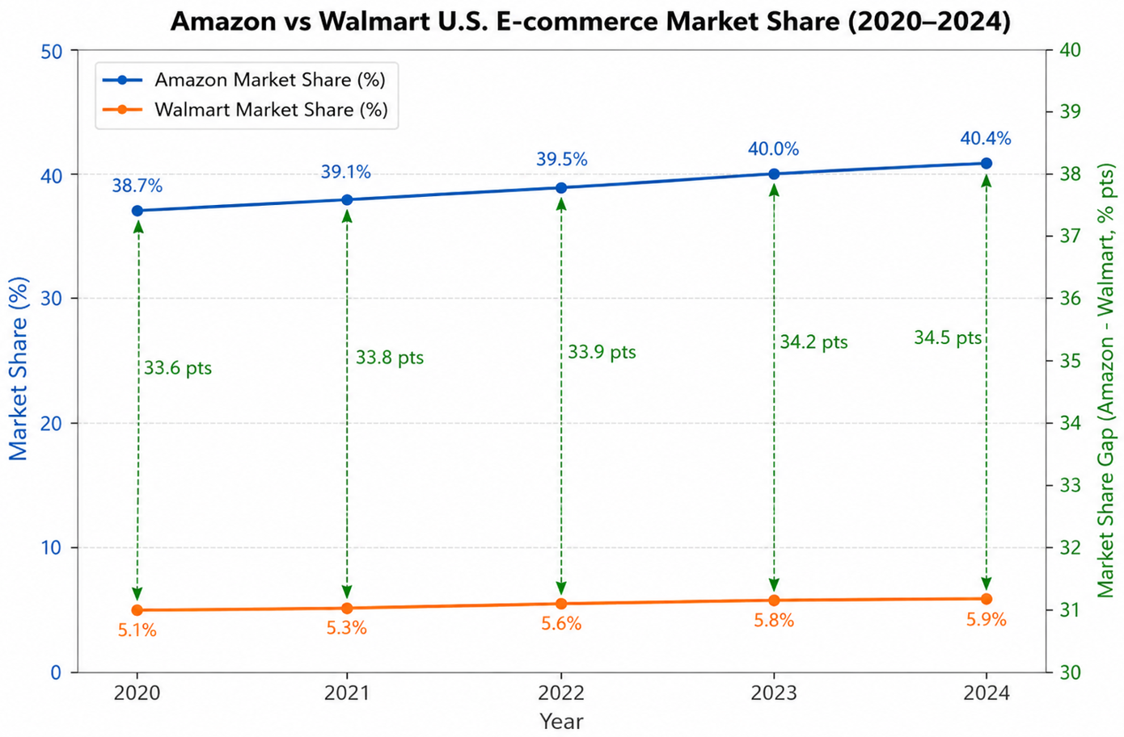
Figure1: Amazon vs Walmart US E-commerce Market Share
• Probability Estimate (P): 0.35 — was derived from the observed market share gap trend between Amazon and Walmart from 2020-2024. The gap increased from 33.6% to 34.5%, indicating sustained competitive pressure. (eMarketer, 2024; Amazon, 2024).
• Impact Estimate (I): $9.8B — A 3-5 percentage point market share loss represents approximately $9.8B in annual revenue exposure based on Walmart's $648B revenue base (Walmart Inc., 2023).
• Expected Loss (EL): $3.43B — Calculated as 0.35 × $9.8B. Monte Carlo simulation produced a 90th percentile loss estimate of $6.2B and a 10th percentile estimate of $1.1B.
• Warning Status: AMBER — Market share is currently between 5.5% and 6.4%, indicating increasing competitive pressure that requires management intervention within 30 days.

4. Quantitative Assessment — R-002: Customer Attrition and Loyalty Erosion
Indicator: Customer Churn Rate Increase
AI-enabled customer experience capabilities deployed by Amazon (Rufus AI, Alexa+) and Target are creating differentiated service levels that Walmart's current systems cannot fully replicate. The indicator measures the quarterly change in Walmart's customer churn rate relative to the pre-AI transformation baseline.
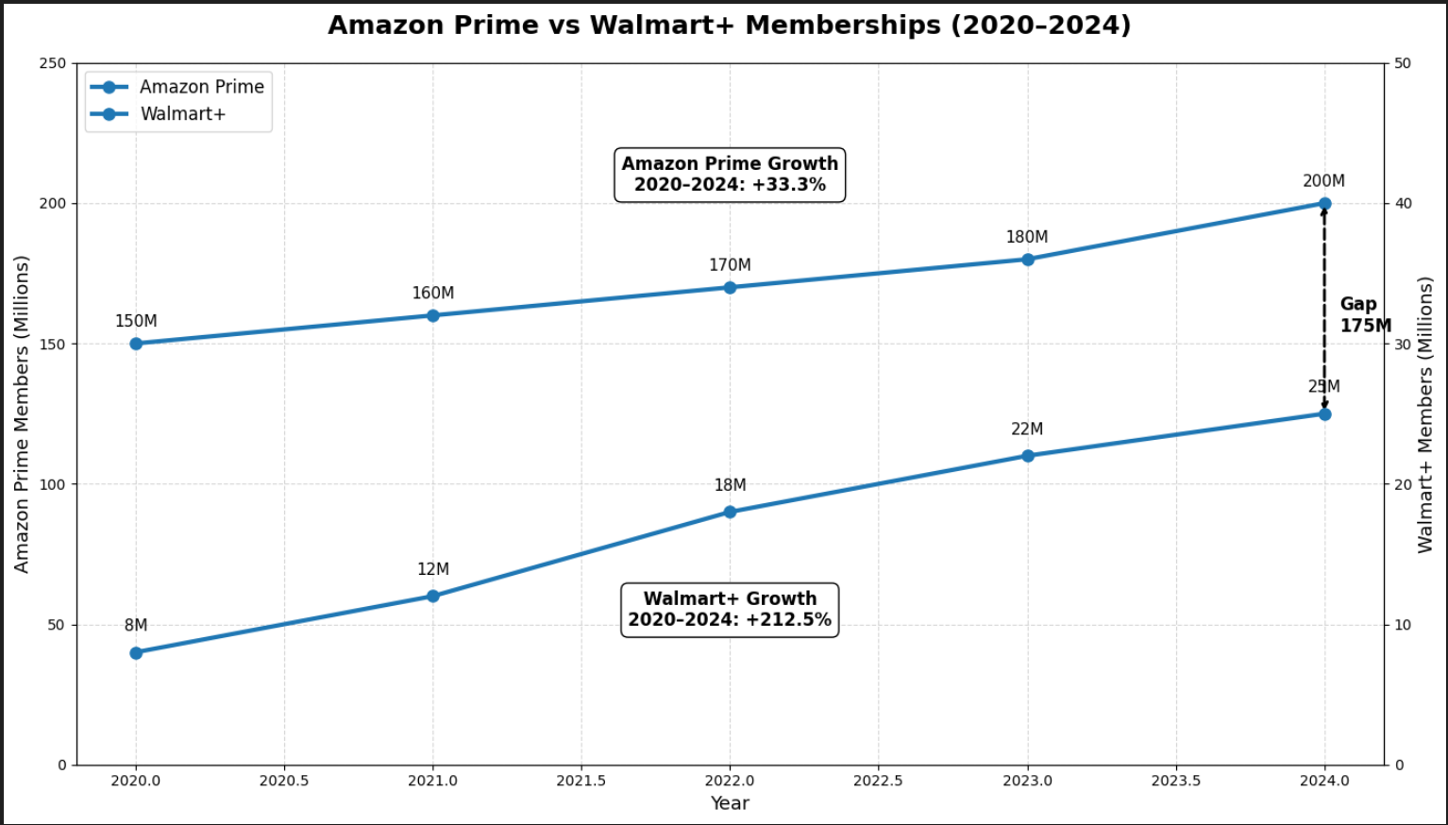
Figure 2: Amazon Prime vs Walmart + Membership
• Probability Estimate (P): 0.42 — Based on industry data showing AI-lagging retailers experienced 12% churn increases in 2024, and Walmart+ membership growth trailing Amazon Prime by a ratio of 1:3 (McKinsey, 2024).
• Impact Estimate (I): $4.2B — Each 1% increase in customer churn rate represents approximately $750M in annual revenue loss. The warning threshold is set at a 4-7% churn rate, implying a potential impact range of $3.0B-$5.25B (Walmart Inc., 2023).
• Expected Loss (EL): $1.76B — Calculated as 0.42 × $4.2B. Monte Carlo simulation produced a 90th percentile loss estimate of $3.8B and a 10th percentile estimate of $0.6B.
• Warning Status: AMBER — Current churn rate trending toward the 4% warning threshold. Machine Learning classification model assigns a 67% probability of threshold breach within 12 months without intervention.

5. Quantitative Assessment — R-003: AI Supply Chain Optimization Opportunity
Indicator: Inventory Turnover Improvement Rate
Walmart's active deployment of AI supply chain tools — including the U.S. Supply Chain Playbook AI initiative — creates a quantifiable opportunity to reduce inventory carrying costs and improve operational efficiency. The indicator measures the quarterly improvement rate in inventory turnover relative to the pre-AI baseline.
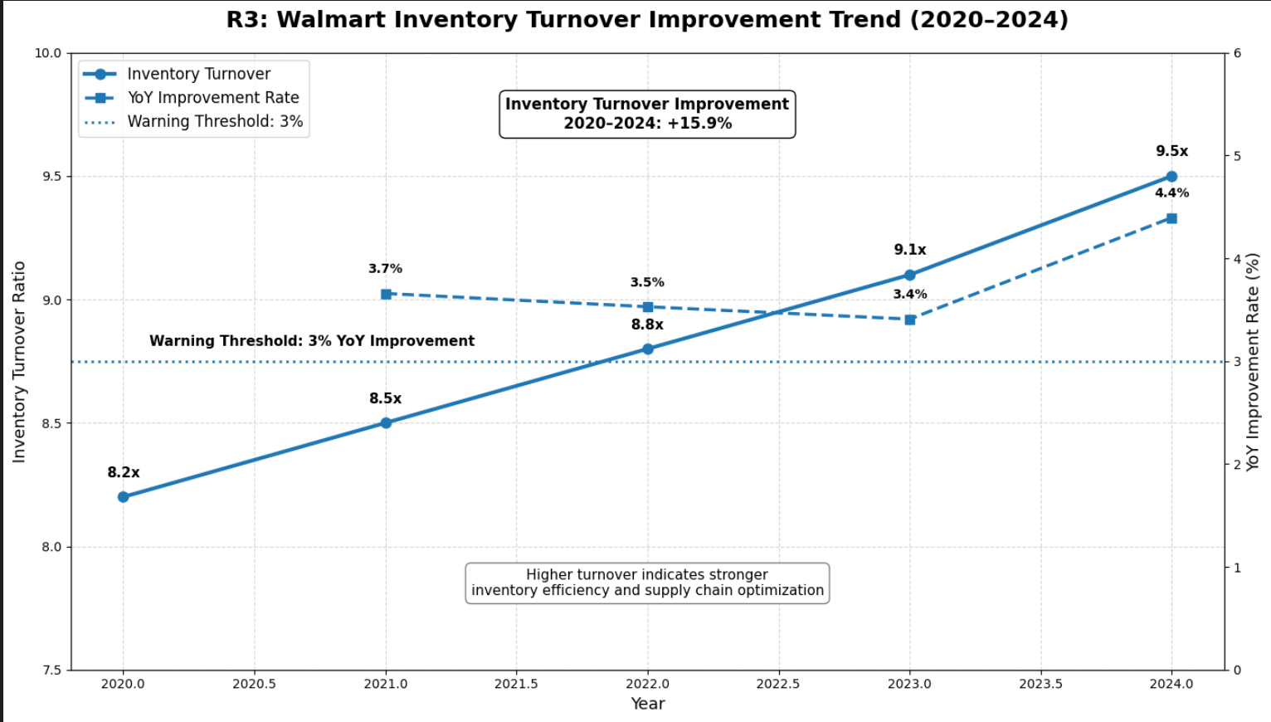
Figure 3: Walmart Inventory Turnover Improvement Trend
• Probability Estimate (P): 0.65 — The probability estimate was supported by Walmart's historical inventory turnover improvement trend and ongoing AI-enabled supply chain initiatives and based on Walmart's active AI supply chain deployment status and McKinsey research indicating AI supply chains achieve 20-30% cost reduction with 65% probability of success within 24 months (McKinsey, 2024; Walmart Inc., 2025).
• Impact Estimate (I): +$5.0B — A 20% reduction in inventory carrying costs on Walmart's $40B+ inventory base generates approximately $5.0B in operating cost savings annually (Deloitte, 2025).
• Expected Gain (EG): +$3.25B — Calculated as 0.65 × $5.0B. Monte Carlo simulation produced a 90th percentile gain estimate of $5.8B and a 10th percentile estimate of $1.2B.
• Warning Status: GREEN — Inventory turnover improvement is currently above the 10% annual target. Machine Learning model assigns an 82% probability of sustained performance above the Green threshold over the next 12 months.

6. I&W Quantitative Assessment Summary
The table below summarizes the quantitative assessment results across all three competitive risks:
Risk # | Risk Description | KRI / Indicator | Likelihood (0-1) | Impact (USD) | Expected Loss (EL = P x I)
R-001 | Market Share Erosion from Competitive AI Disruption | E-Commerce Market Share % Decline Rate | 0.35 | $9.8B | $3.43B
R-002 | Customer Attrition and Loyalty Erosion | Customer Churn Rate Increase | 0.42 | $4.2B | $1.76B
R-003 | AI Supply Chain Optimization Opportunity | Inventory Turnover Improvement Rate | 0.65 | +$5.0B | +$3.25B
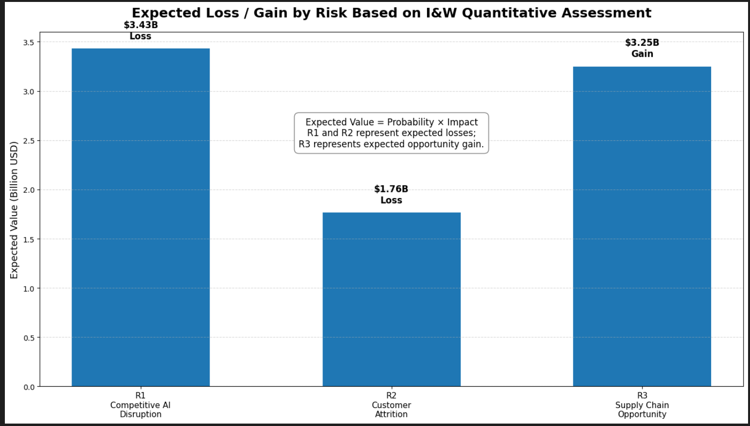
Figure 4: Expected Loss / Gain by risk based on I & W Quantitative Assessment
From table and figure 4, it summarizes the expected loss or gain for each risk based on the I&W quantitative assessment. R1 has the highest expected loss at $3.43B, followed by R2 at $1.76B. R3 is treated as an opportunity risk, with an expected gain of $3.25B. This comparison helps prioritize risk response by translating probability and impact estimates into a common financial measure.

7. Monte Carlo Simulation and Machine Learning Validation
Monte Carlo Simulation
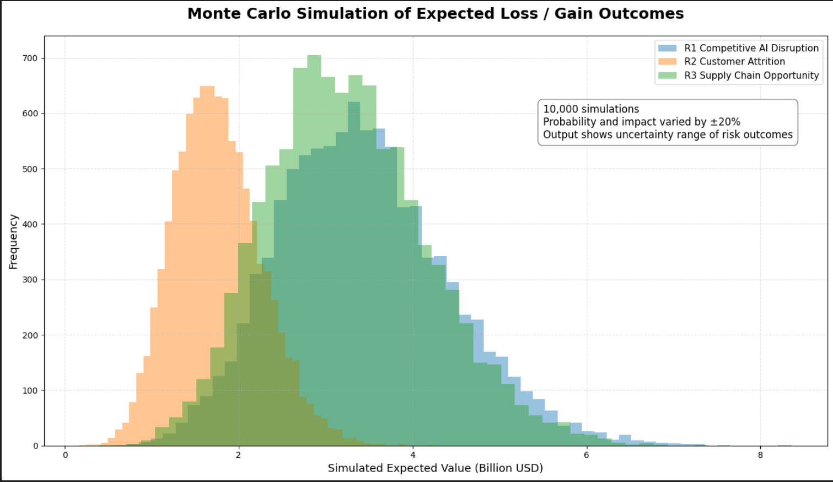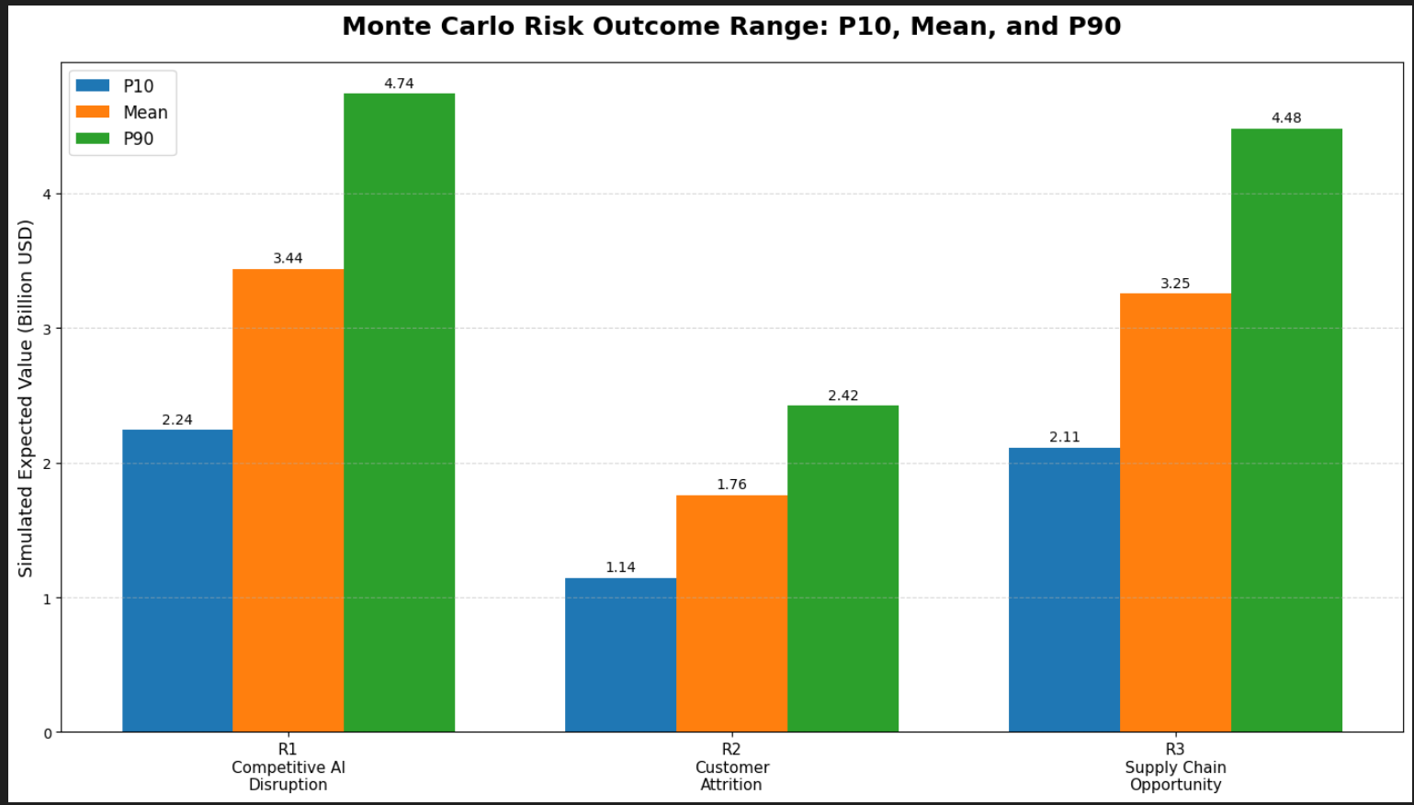
Figure 5 & 6: Monte Carlo Simulation of Expected Loss/ Gain outcome, Risk Outcome Range
Monte Carlo simulation was applied across 10,000 iterations for each risk, varying probability and impact inputs within defined uncertainty ranges (±20%). The Python-based Monte Carlo simulation generated 10,000 outcomes for each risk by varying both probability and impact assumptions within a ±20% uncertainty range. The results show that R1 has the largest downside exposure, with a higher P90 loss outcome than R2. R3 shows a positive opportunity distribution, indicating that AI-enabled supply chain optimization may generate measurable operational value if implementation targets are achieved.
Random Forest Machine Learning
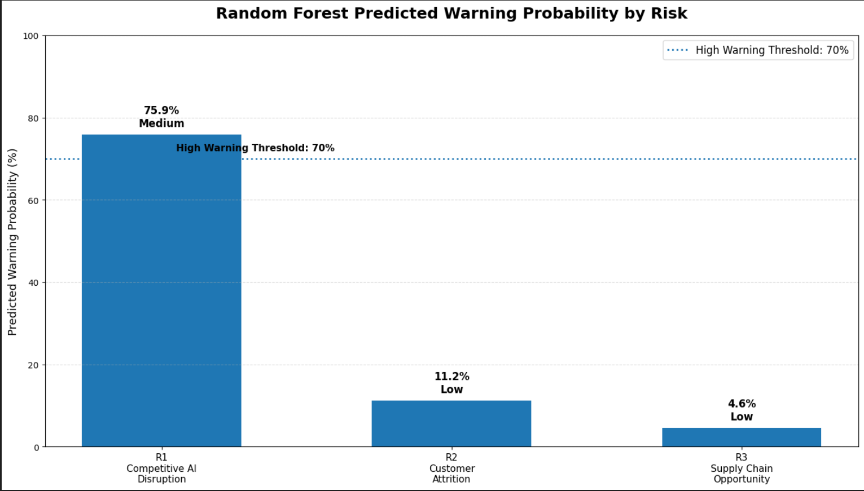
Figure 7: Random Forest Predicted Warning Probability by Risk
A Random Forest classification model was developed using 500 scenario based I&W observations generated from public market data, financial indicators, and defined warning thresholds. Because Walmart-specific AI risk event data and customer churn data are not publicly available, the model was used as a scenario validation tool rather than a fully predictive historical model. The model incorporated indicators such as market share gap, customer loyalty gap, inventory turnover, competitor AI pressure, and revenue exposure.
From result, Random Forest results show which I&W indicators have the strongest influence on warning status classification. Feature importance analysis helps validate the I&W framework by identifying the indicators that most strongly contribute to Low, Medium, or High warning outcomes. The predicted warning chart further supports management prioritization by showing which risks are more likely to approach Amber or Red warning thresholds.
The combined I&W, Monte Carlo, and ML analysis framework provides Walmart's risk management team with a quantitatively grounded basis for resource allocation, mitigation prioritization, and board-level risk reporting.

References
Amazon.com, Inc. (2024). Annual report 2023. https://ir.aboutamazon.com
COSO. (2017). Enterprise risk management: Integrating with strategy and performance. Committee of Sponsoring Organizations of the Treadway Commission. https://www.coso.org
Deloitte. (2025). Retail and supply chain industry insights. https://www.deloitte.com/us/en/industries/retail-distribution.html
eMarketer. (2024). US ecommerce market share 2024. https://www.emarketer.com
McKinsey & Company. (2024). Supply chain and operations insights. https://www.mckinsey.com/capabilities/operations/our-insights
Walmart Inc. (2023). Annual report on Form 10-K for the fiscal year ended January 31, 2023. U.S. Securities and Exchange Commission. https://stock.walmart.com/sec-filings
Walmart Inc. (2025). Walmart's U.S. supply chain playbook goes global. https://corporate.walmart.com/news

